**BUAN 6346 Bigdata Analytics**

**Assignment 2**

**Submitted by**

**Geethika Veluri**

**Q1. a.What are the hashtags used and how many times each are used?**

**Step 1: Importing into Hive from Desktop**

***drop table if exists twit_json;***

***create table twit_json(json string);***

***load data local inpath 'Desktop/Twitter.json' overwrite into table twit_json;***

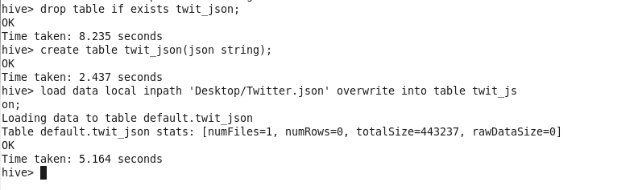

**Step 2: Reading the Json data into columns**

***drop table if exists twit_out;***

***create table twit_out as***

***select get_json_object(json, '$.id') as Id,***

***get_json_object(json, '$.text') as text from twit_json;***

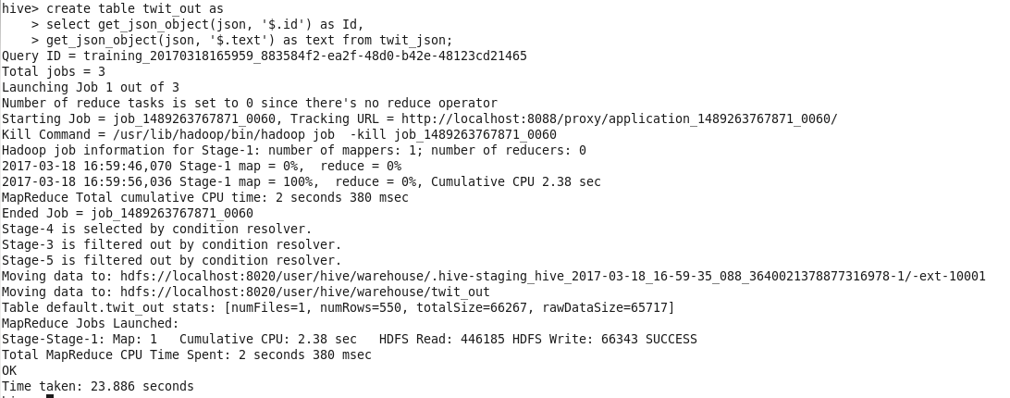

**Step 3: Filter out the hashtags and count then number**

***drop table if exists hashtag_count;***

***create table hashtag_count as SELECT word, count(1) as wcount FROM twit_out***

***LATERAL VIEW explode(split(text,' ')) text_ex as word***

***WHERE word LIKE '#%'***

***GROUP BY word***

***ORDER BY wcount DESC ;***

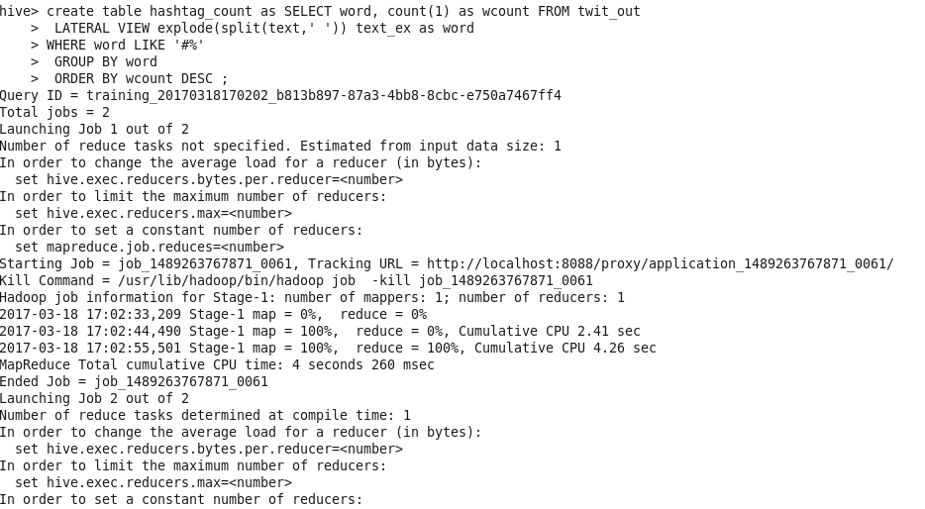

**Output: This output shows Top 10 Hashtags out of total 70 Hashtags**

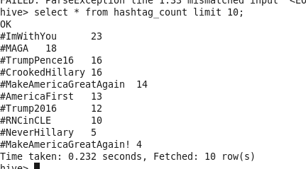

**Q1. b. What is the most trending hashtag in a day and how many times is it tweeted? [Note: day should be in the format ‘yyyy-mm-dd’]**

**Step1: Reading JSON data into columns**

***drop table if exists text_hashtags;***

***create table text_hashtags as***

***select get_json_object(json, '$.text') as text,***

***unix_timestamp(get_json_object(json, '$.created_at'),'EEE MMM dd HH:mm:ss Z yyyy') as Date***

***from twit_json;***

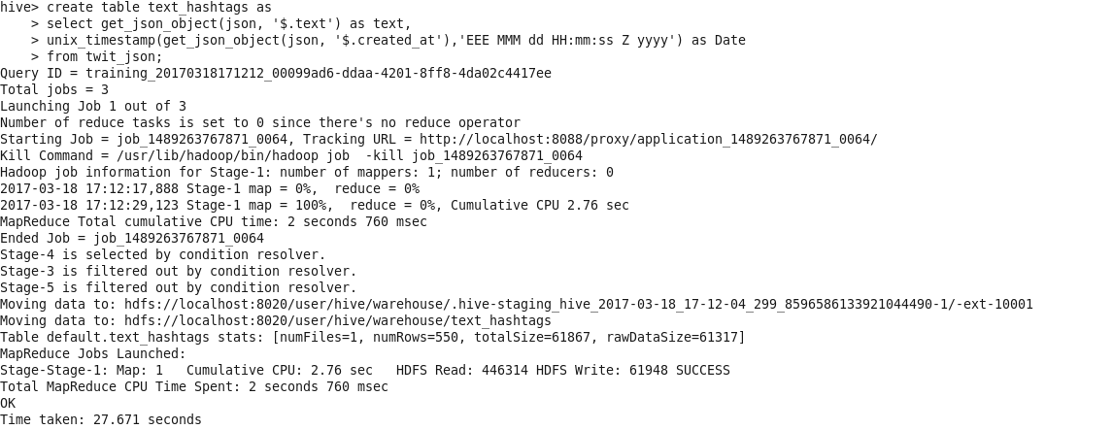

**Step 2: Converting date format and extracting the words from text**

***drop table if exists date_hashtags;***

***create table date_hashtags as***

***SELECT from_unixtime(Date,'yyyy-MM-dd') as dt, word FROM text_hashtags***

***LATERAL VIEW explode(split(text,' ')) text_ex as word***

***WHERE word LIKE '#%';***

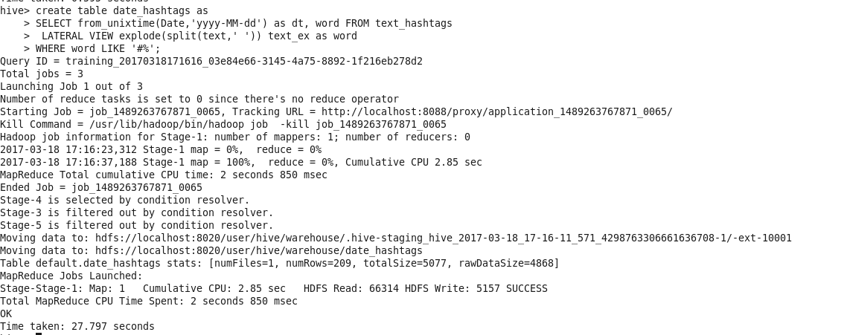

**Step 3: Counting the number of Hashtags each day**

***drop table if exists hashtag_count;***

***create table hashtag_count as***

***select dt, word, count(word) as wcount from date_hashtags***

***GROUP BY dt, word***

***ORDER BY wcount DESC ;***

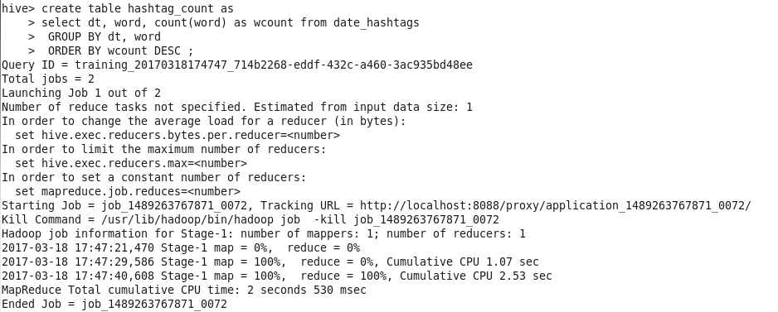

**Step 4: Extracting the Hashtag used the most in a day**

***drop table if exists highest_hashtag_count;***

***create table highest_hashtag_count as***

***select * from (***

***select dt, word, wcount,***

***rank() over (partition by dt order by wcount desc) as rank***

***from hashtag_count) c where rank = 1;***

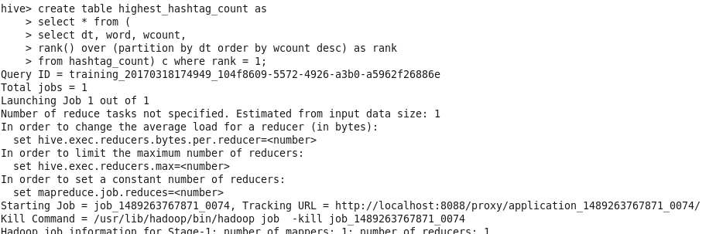

**Output: 15 rows are shown in screenshot below out of 37 rows. The third column represents the frequency and the fourth column represents rank.**

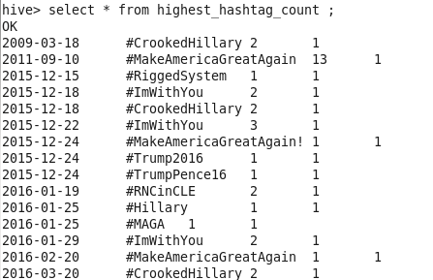

**Q1. c. Which state users are most active and how many tweets are posted by State?**

**Step 1: Reading the JSON data into columns**

***drop table if exists location_data;***

***create table location_data as***

***select get_json_object(json, '$.user.location') as location,***

***get_json_object(json, '$.retweet_count') as retweet_count***

***from twit_json;***

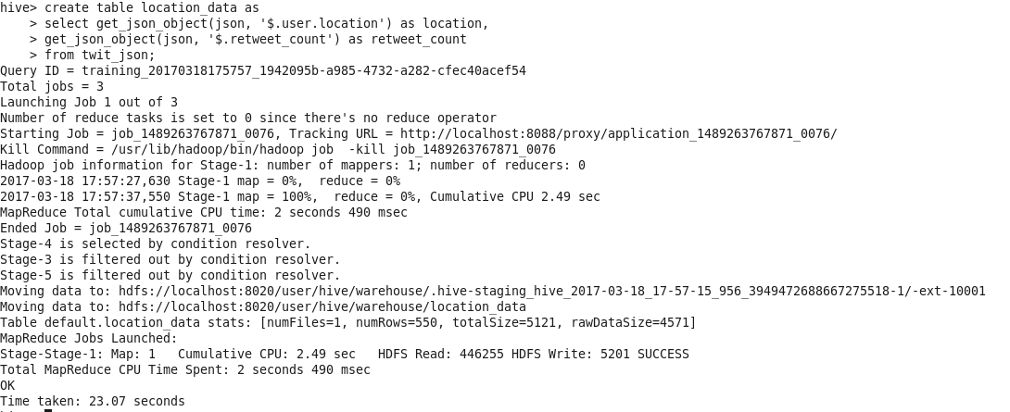

**Step 2: Counting the number of users by location**

***drop table if exists location_count;***

***create table location_count as SELECT location, count(location) as loc_count FROM location_data***

***GROUP BY location***

***ORDER BY loc_count DESC ;***

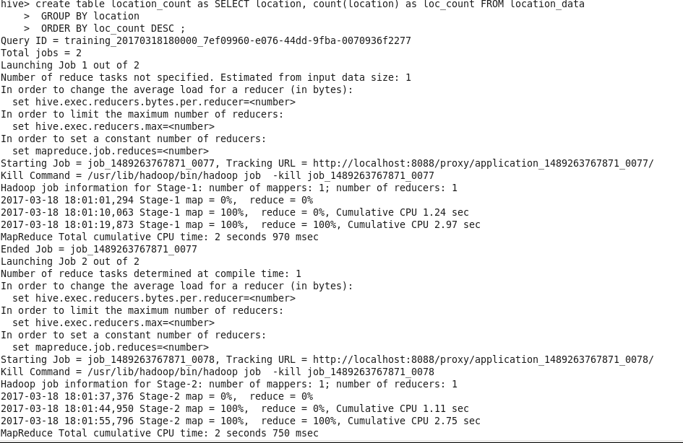

**Output: California has the most active users**

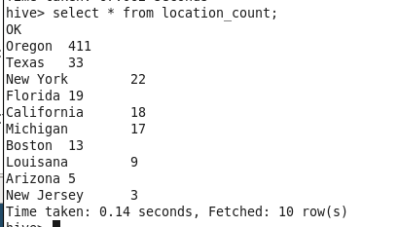

**Q1. d. Based on the user’s followers count, who are the top ten users who have tweeted?**

**Step 1: Reading the JSON data into columns**

***drop table if exists User_followers;***

***create table User_followers as***

***select get_json_object(json, '$.user.id') as user_id,***

***get_json_object(json, '$.user.followers_count') as fol_count***

***from twit_json;***

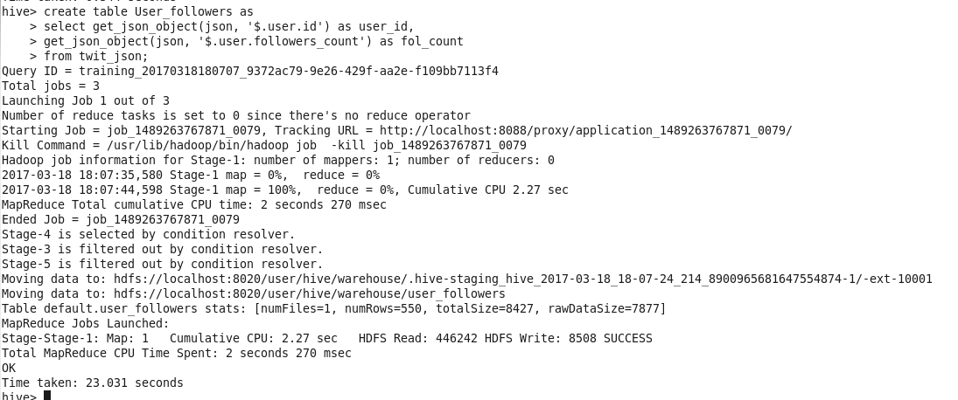

**Step 2: Sorting the users by user followers count**

***drop table if exists User_Follower_count;***

***create table User_Follower_count as SELECT user_id, sum(fol_count) as User_fol_count FROM User_followers***

***GROUP BY user_id***

***ORDER BY User_fol_count DESC ;***

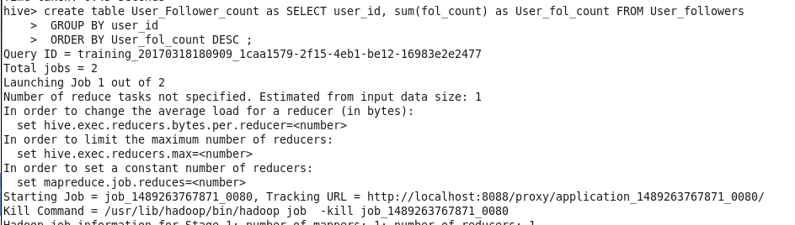

**Output: Top 10 users based on followers count**

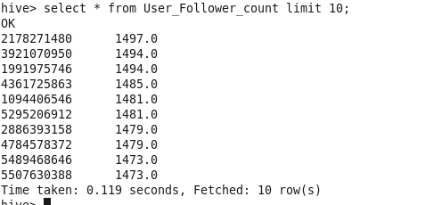

**Q1. e. What is the score for each tweet that was posted? Does the tweet have a positive or negative sentiment?**

**Step 1: Reading JSON data into columns**

***drop table if exists User_data;***

***create table User_data as***

***select get_json_object(json, '$.id') as Tweet_id,***

***get_json_object(json, '$.user.name') as User_name,***

***get_json_object(json, '$.text') as text,***

***unix_timestamp(get_json_object(json, '$.created_at'),'EEE MMM dd HH:mm:ss Z yyyy') as Date***

***from twit_json;***

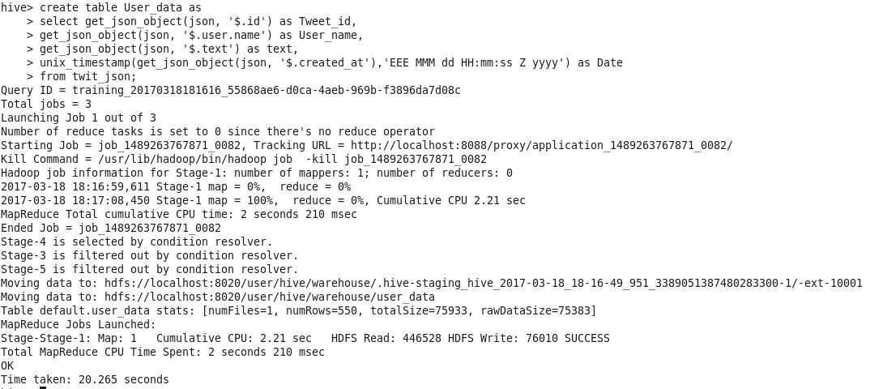

**Step 2: Split the text into words for each tweet**

***drop table if exists User_tweet_split;***

***create table User_tweet_split as***

***SELECT Tweet_id, User_name, from_unixtime(Date,'yyyy-MM-dd') as dt, word FROM User_data***

***LATERAL VIEW explode(split(text,' ')) text_ex as word;***

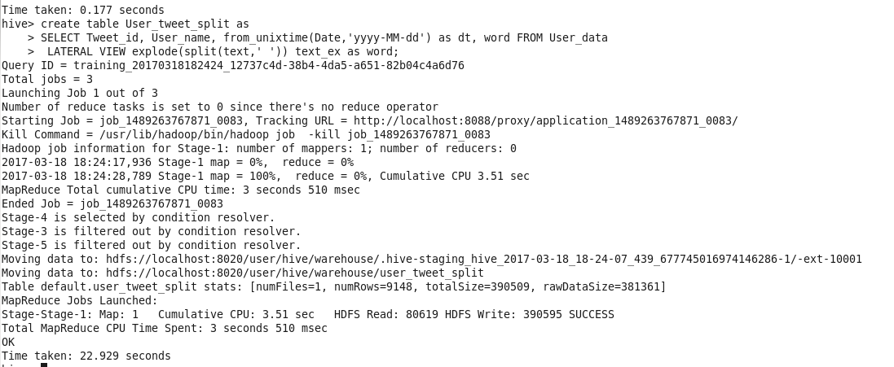

**Step 3: Reading the dictionary data into hive**

***drop table if exists dictionary;***

***create table dictionary (Dict_word string, score string) row format delimited fields terminated by '\t';***

***load data local inpath 'Desktop/Dictionary.txt' overwrite into table dictionary;***

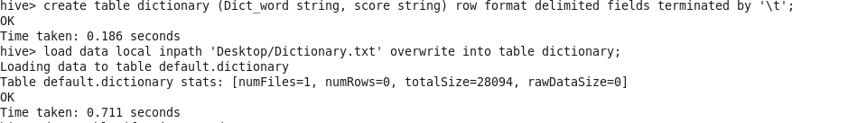

**Step 4: Mapping the scores from dictionary to twitter data**

***drop table if exists word_scores;***

***create table word_scores as***

***select u.Tweet_id, u.User_name, u.dt, u.word, d.score from User_tweet_split u left outer join***

***dictionary d on (u.word = d.dict_word);***

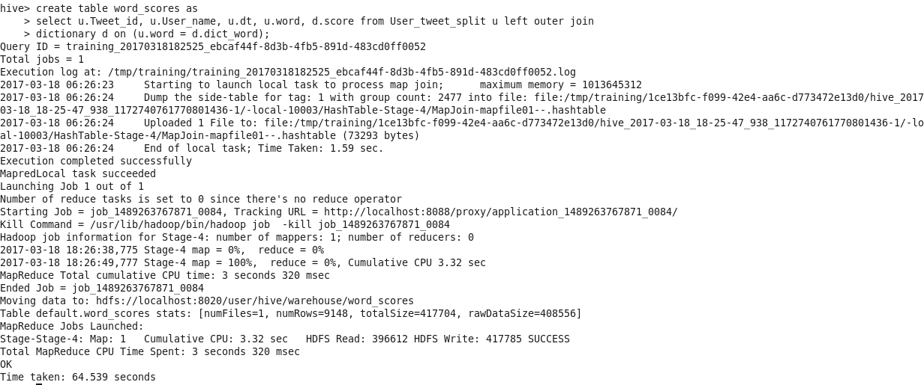

**Step 5: Average the score of words by tweet id**

***drop table if exists tweet_score;***

***create table tweet_score as***

***select Tweet_id, User_name, dt, avg(score) as tweet_score from word_scores***

***group by Tweet_id, User_name, dt;***

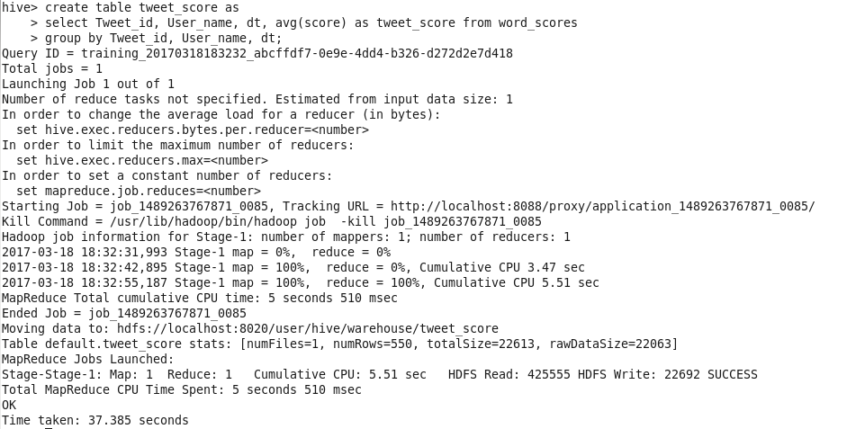

**Step 6:**

***drop table if exists tweet_sentiment;***

***create table tweet_sentiment as***

***select Tweet_id, User_name, dt,***

***case***

***when tweet_score > 0 then 'positive'***

***when tweet_score < 0 then 'negative'***

***else 'None'***

***end as tweet_sentiment***

***from tweet_score;***

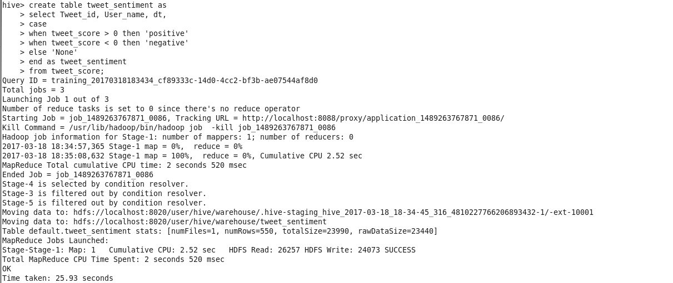

**Output: Out of 550 tweets, the sentiment is shown for 10 tweets in the screen shot below.**

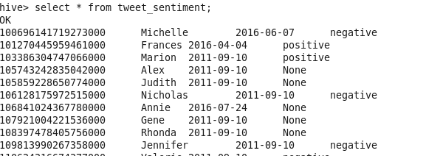

**Q2. Did you find any problem in the previous question? If so briefly explain what exactly the problem is and what solution would you propose.**

Problem: The score given in the data dictionary is very subjective. For example, the word ‘condemn’ or ‘condemnation’ have negativity associated with it. But in the dictionary ‘condemn’ is given positive score and ‘condemnation’ is given negative score. The sentiment of the tweet is not accurately captured because of this reason.

Solution: The score should be assigned based on the connotative meaning of the word. Also, the list of words in the dictionary used should be made as exhaustive as possible to capture the sentiment of the tweet accurately.